Educational Organisation Using ServiceNow

**Team ID**: NM2025TMID15365

**Team Members:**

**Team Leader:** GOWTHAM.S

**Team Member 1:** PRAVEEN KUMAR.L

**Team Member 2:** PARTHIBAN.A

**Team Member 3:** PAUL KUMAR.K

# Problem Statement :

The project EducationalOrganisationusingServiceNow was developed as part of the Naan Mudhalvan initiative, focuses on modernizing and digitalizing student admission and academic progress management using ServiceNow platform.

Educational institutions oftenface challenges in managing student admissions and academic progress due to manual record-keeping, slow admission processes, and scattered student data across different systems. These inefficiencies lead to delays, errors, and difficulties in tracking student performance effectively.

# Objectives :

* To configure a ServiceNow instance for managing educational information.
* To design custom tables for handling Admissions and Student Progress.
* To automate data entry field updates using Client Scripts.
* To implementworkflows for managing admission status processes.
* To improve data accuracy through validation, choice fields, and automated updates.

# Tools and Technologies :

* Platform: ServiceNow (Developer Instance)
* Modules Used: Tables, Forms, Update Sets, Client Scripts, Process Flows
* Įanguages: JavaScript (for client scripts)

# Skills Used:

* ServiceNow Tables
* Forms & Form Design
* Update Sets
* Client Scripts (JavaScript)
* Process Flow / Workflow

# Milestone 1: ServiceNow instance setup

* Sign up at the ServiceNow Developer Site.
* Request a Personal Developer Instance and submit the details.
* Use the credentials sent via email to log in and start navigating ServiceNow.

# Milestone 2: Creating a Update Set

* Navigate to All → **Local Update Sets**.
* Click New to a new update set.
* Enter Name: Educational Organisation.
* Submit and mark it as Current.

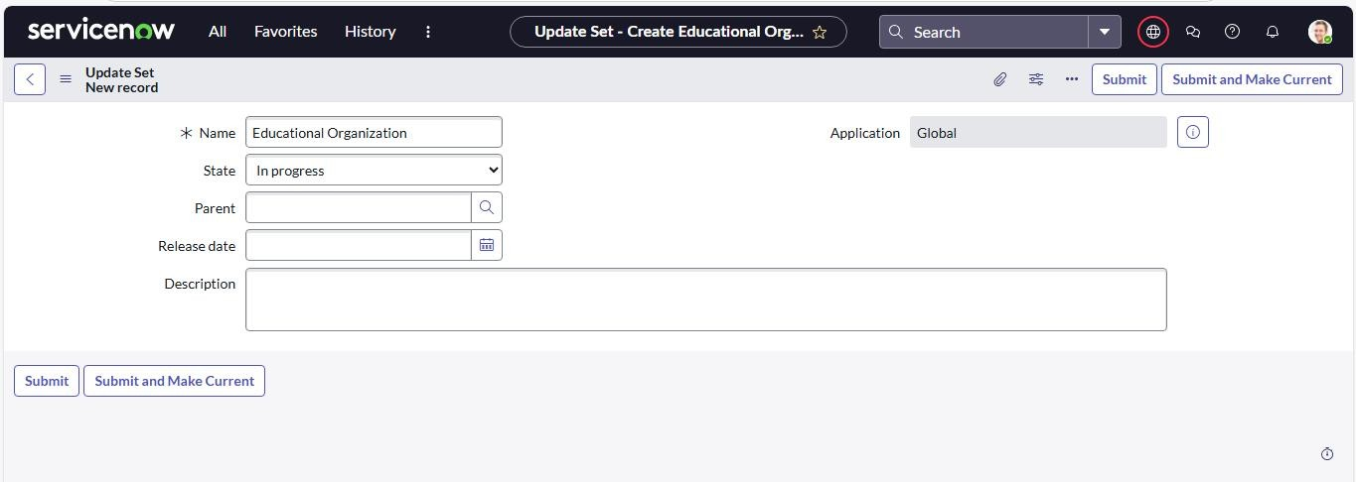

# Milestone 3: Creating a Table

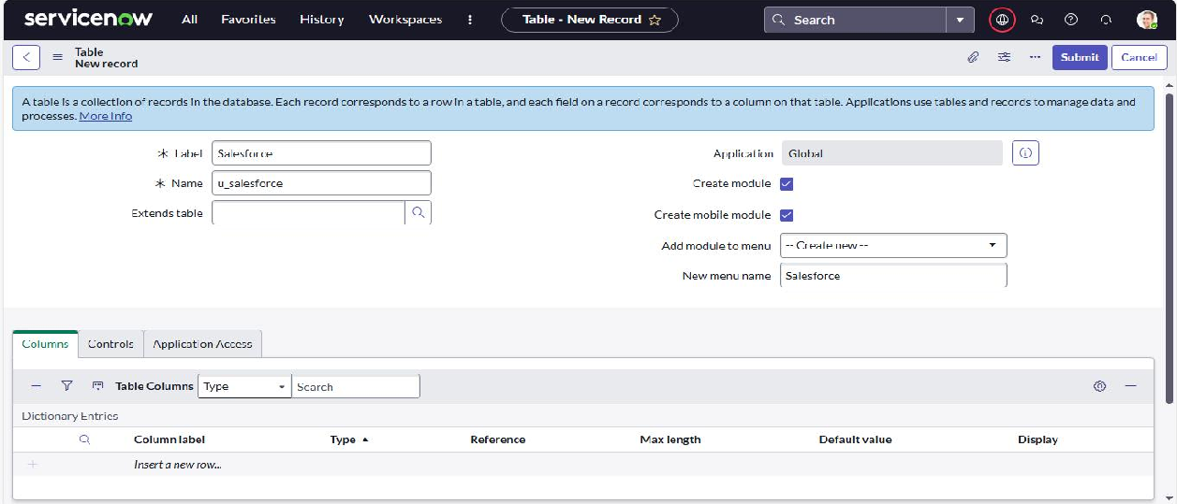

Activity 1: Creating Salesforce Table

* Go to All **→ Tables** and click **New**.
* Enter **Label: Salesforce** → API name is generated automatically.
* Add the required columns by double-clicking the column label, entering details, and assigning the proper type.
* For **Admin Number:**
  + Set **Display = True** and save.
  + Under **Controls**, enable **Extensible**.
  + Open the **Admin Number** column → go to **Advanced View** → **Default View.**
  + Enable **Use Dynamic Default** and select **Get Padded Numbe**r.
* For **Grade** column define choices with **Labe**l, **Value**, and **Sequence**.

## Activity 2: Admission Table

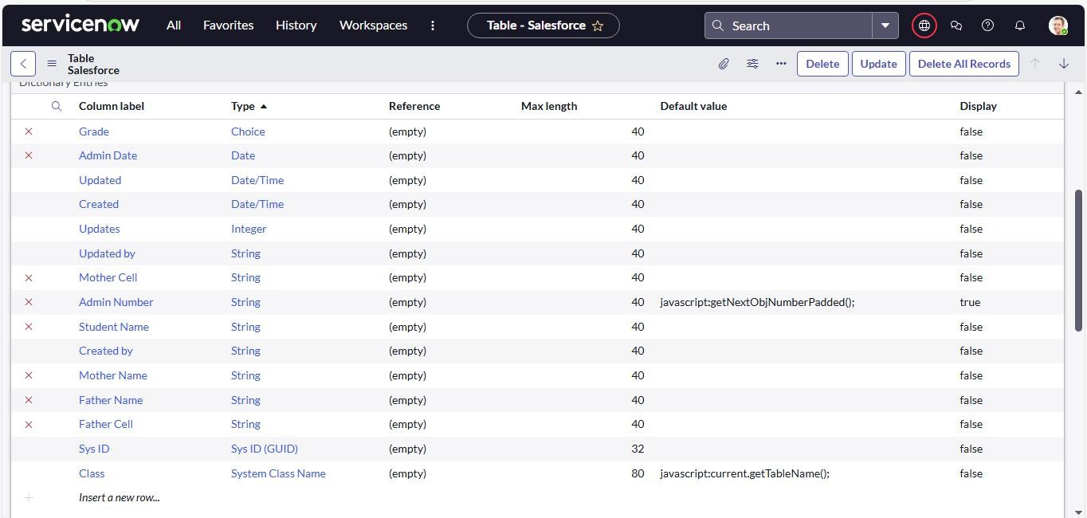

* Create a new table named **Admission**.
* Set **Extends Table = Salesforce** and select **Add Module to Menu = Salesforce**.

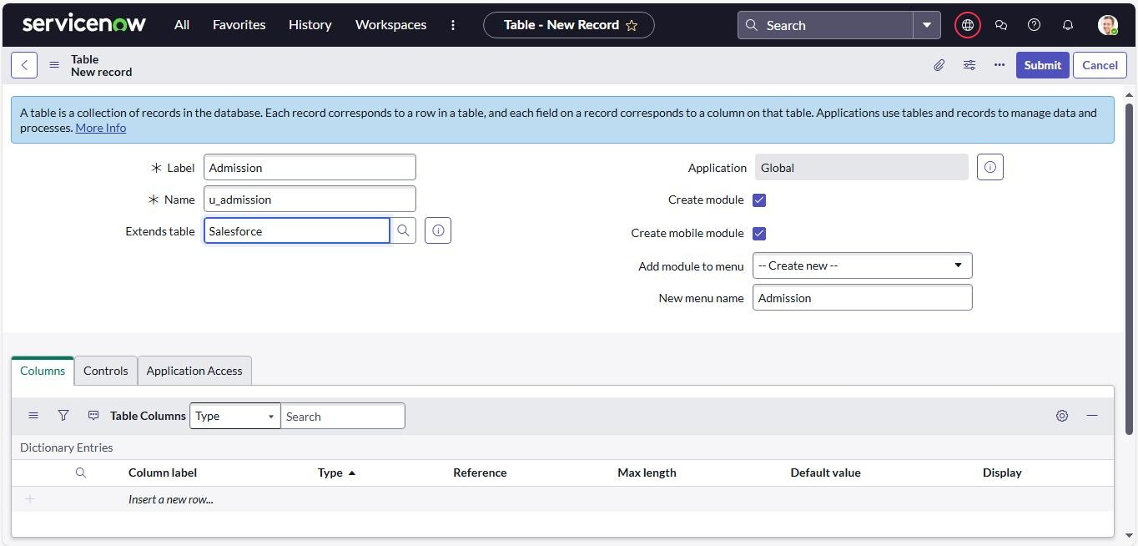

* Add the required fields for capturing admission details.
* Configure choice fields for:
  + **Admin Status** (New, In Progress, Joined, Rejected, Rejoined, Closed, Cancelled).
  + **Pincode** (mapped to Mandal, City, District).
  + **Purpose of Join** ( add multiple options as needed).
  + **School** (list of schools).

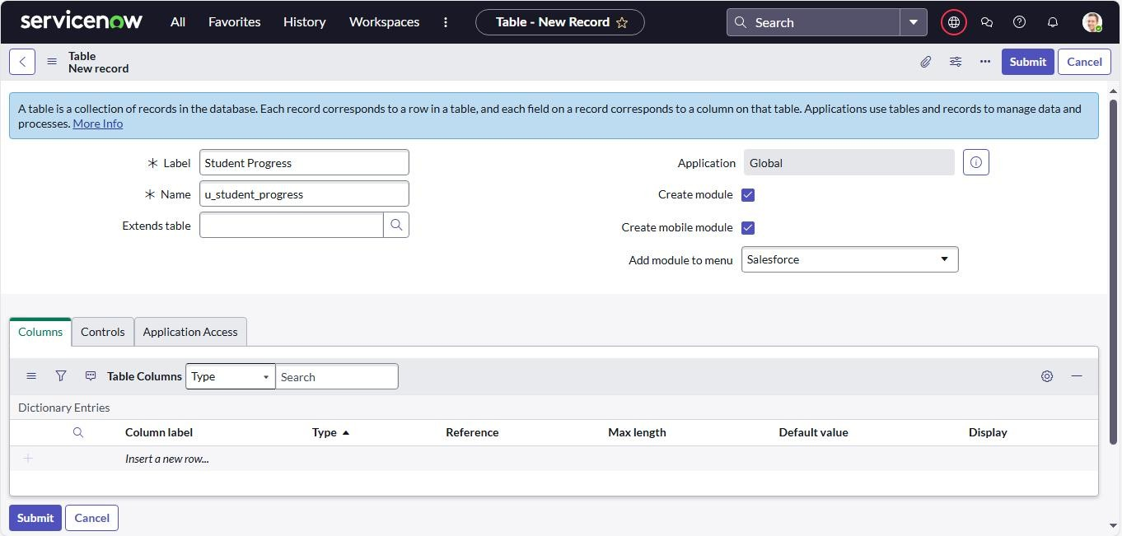

* + **School Area** (gegraphical areas).

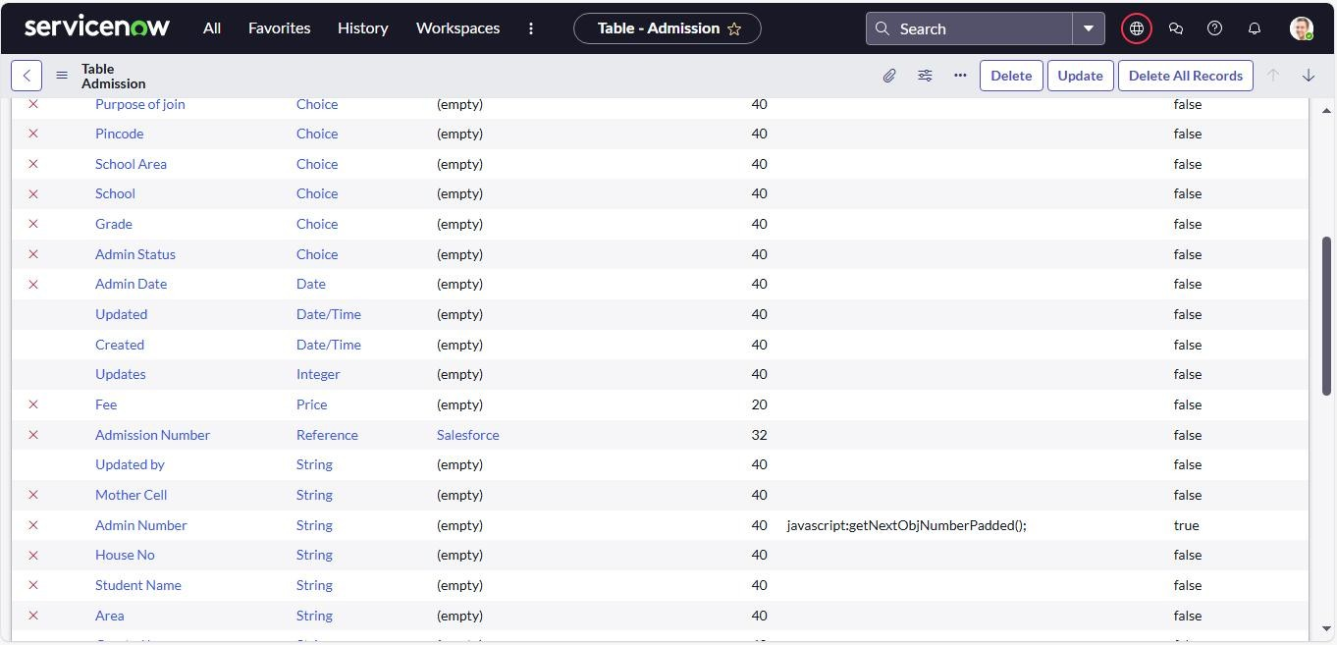

## Activity 3: Student Progress Table

* Create a table named **Student Progress** with the required columns.

## Select Add Module to Menu = Salesforce.

* Add subject fields: **Telugu**, **Hindi**, **English**, **Maths**, **Science**, **Socia**l.
* Create calculated fields for **Total Marks**, **Percentage**, and **Result**.

**Milestone 4:** Configuring Table Layout

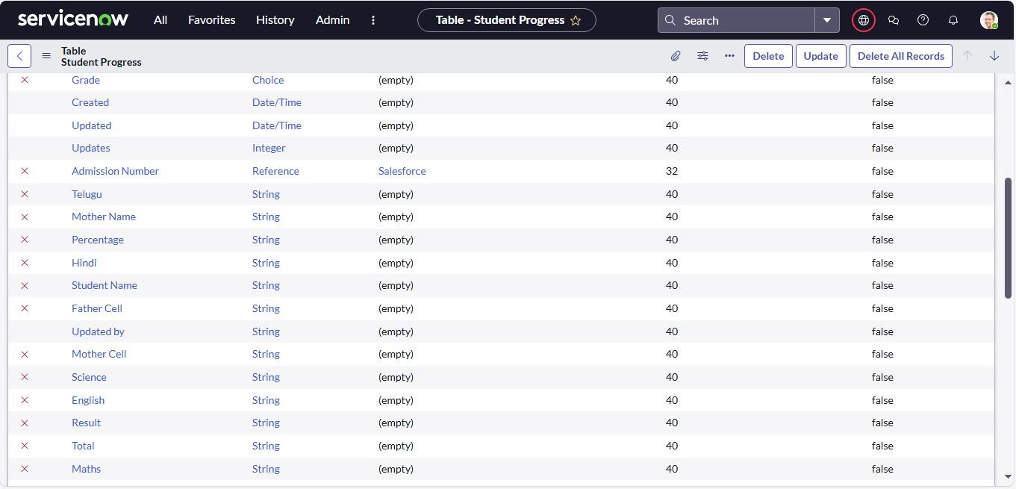

* Open the **Student Progress Table** and go to Layout Form.
* Select **Admission Number [+]**.
* Move the required Admission Number fields from the **Available** list to the **Selected** list.
* Save the layout.

**Milestone 5:** Form Design

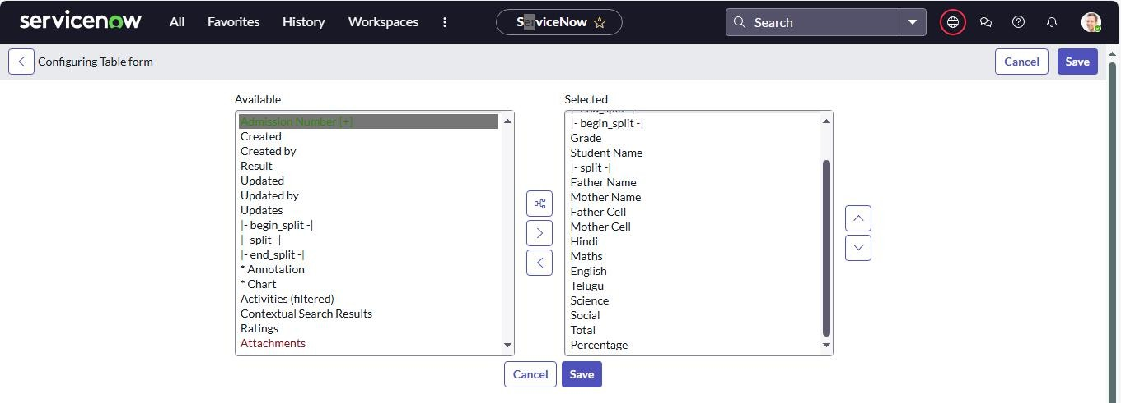

## Activity 1: Salesforce Table

* Navigate to **All → System Definition → Tables**.
* Search for **Salesforce** and open it.
* Right-click the toggle at the top and choose **Configure → Form Design**.
* From the dropdown, select **Salesforce (u_salesforce)**.
* Drag and drop the required fields into the layout.
* Save the form design.

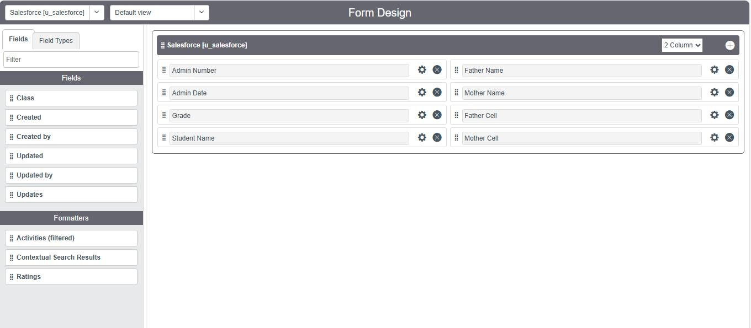

## Activity 2: Admission Table

* Repeat the same steps as Salesforce Table design.
* Configure the required fields and save.

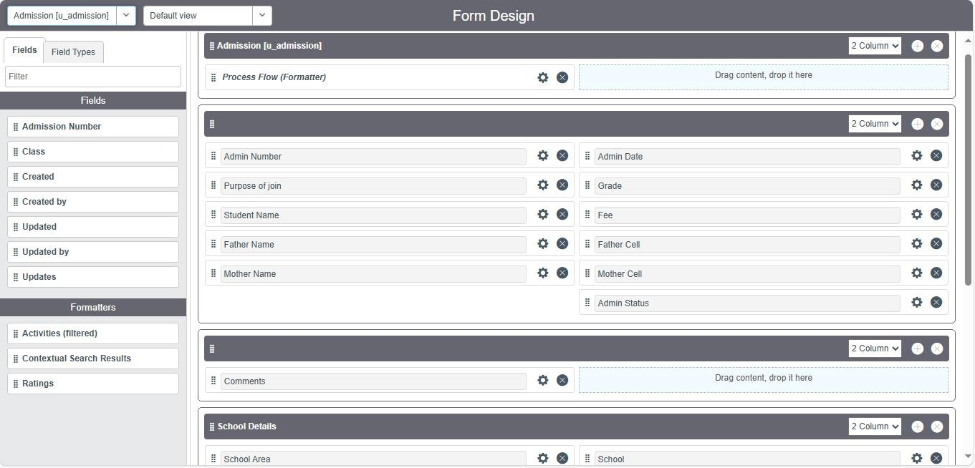

## Activity 3: Student Progress Table

* Follow the same steps as above.
* Configure the required fields for Student Progress and save.

**Milestone 6:** Number Maintenance

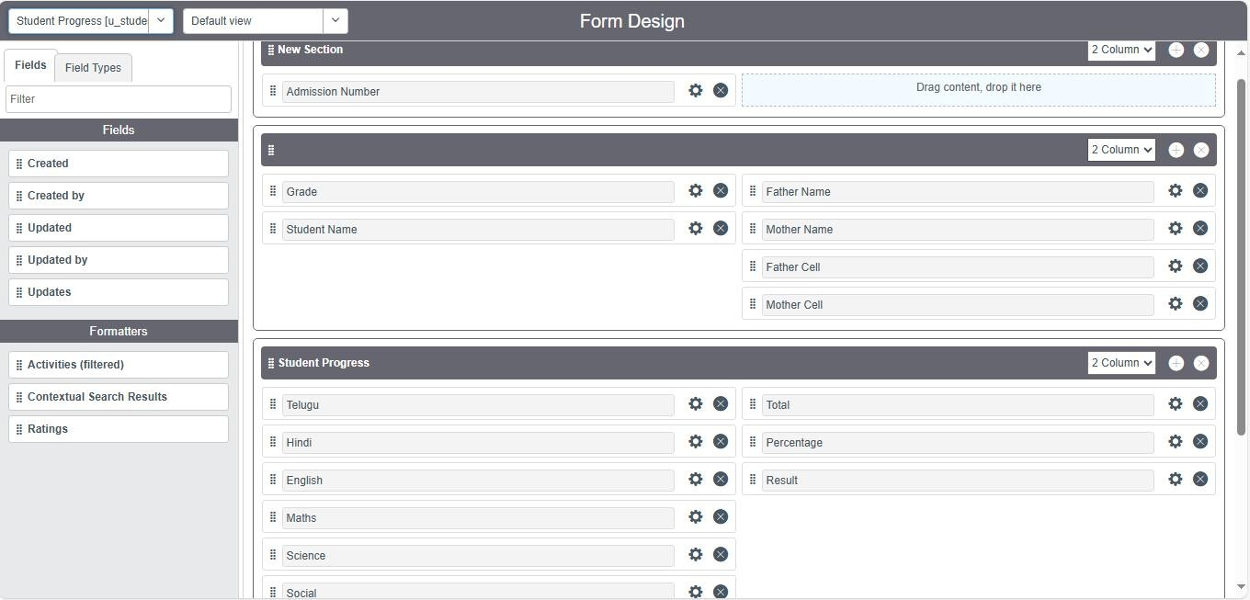

* Navigate to **All → Number Maintenance → New**.
* Fill the details for the **Admin Number**.
* Click **Submit**.

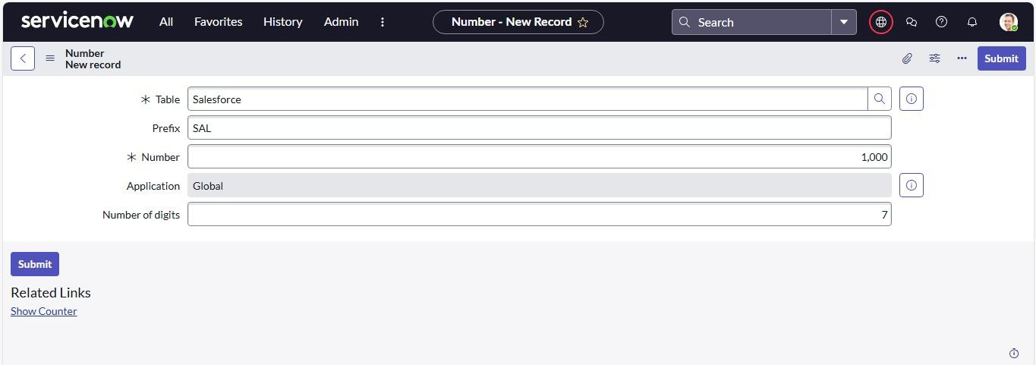

**Milestone 7:** Process Flow

* Navigate to **All → Process Flow → New**.
* Enter the required details and click **Save**.
* Replace the **Name** and **Label** with the correct values and choose **Insert and Stay**.

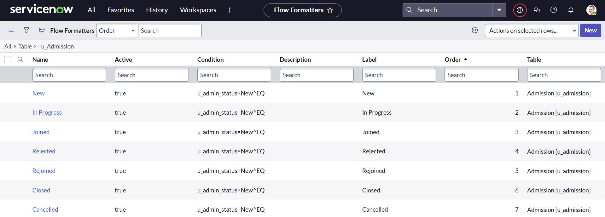

* Arrange the admission statuses in the following order:
  + New → In Progress → Joined → Rejected → Closed → Cancelled.

**Milestone 8:** Client Script

## Activity 1: Create “Auto Populate” Client Script for Admission Table

* Go to All → Client Scripts → New.
* Fill in the details for the script.
* Add the JavaScript code to auto-fill admission details (date, grade, student name, parents details, contact info).
* Enable Isolate Script and Save.
* Note: Enable that the field names in the script match the ones created in the Admission Table.

## Activity 2: Create “Pincode Update” Client Script for Admission Table

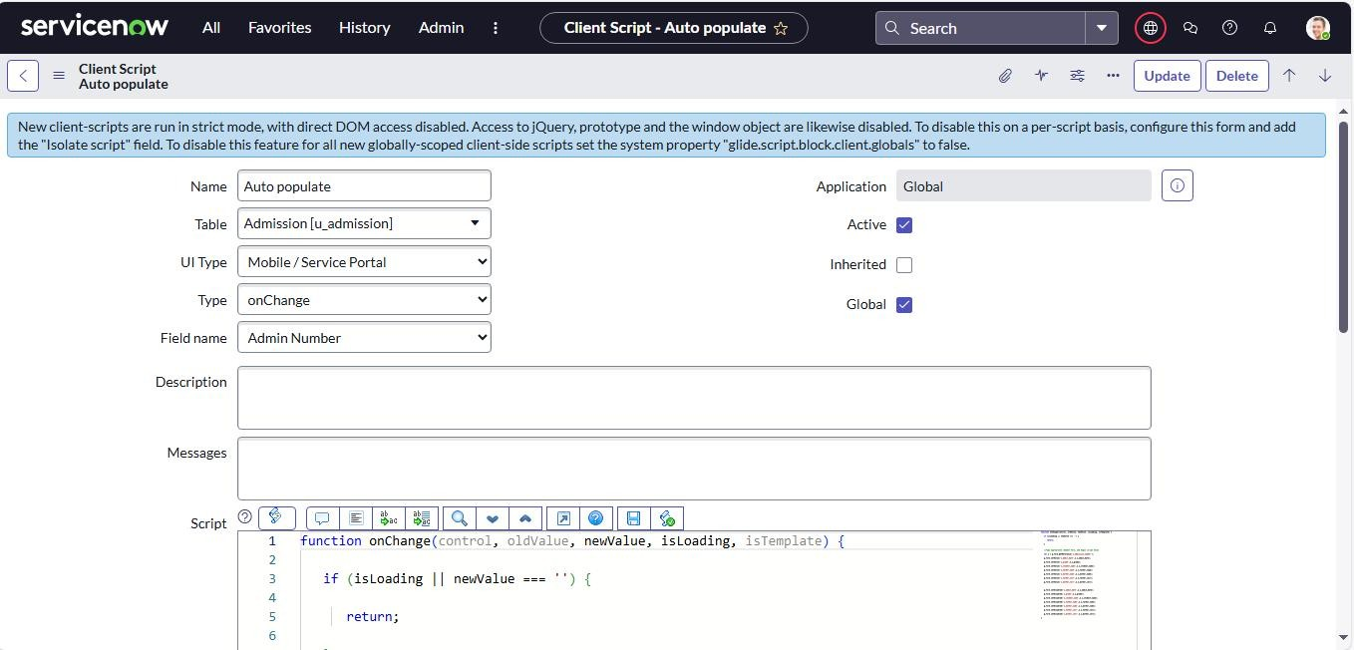

* Go to All → Client Scripts → New.
* Fill in the Script details.
* Add the JavaScript code to auto-fill Mandal, City, and District based on the entered Pincode.
* Enable Isolate Script and Save.
* Example:
  + 509358 → Kadthal, RangaReddy
  + 500081 → Karmanghat,RangaReddy
  + 500079 → Abids, Hyderabad

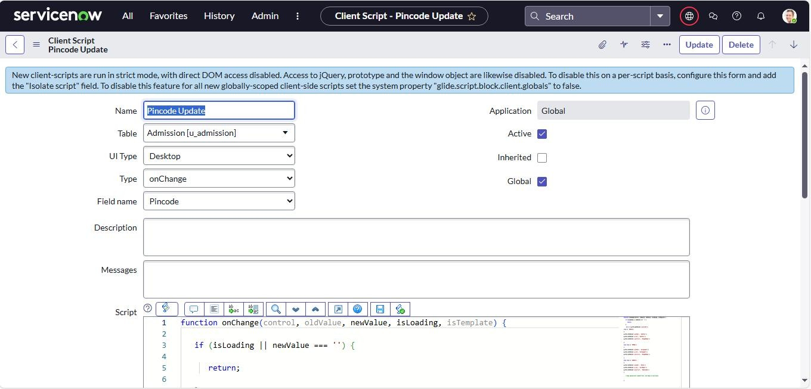

## Activity 3: Create “Disable Fields” Client Script for Student Progress Table.

* Go to All → Client Scripts → New.
* Fill in the script details.
* Add the JavaScript code to disable Total, Percentage, and Result fields so they cannot be edited manually.
* Enable Isolate Script and Save.

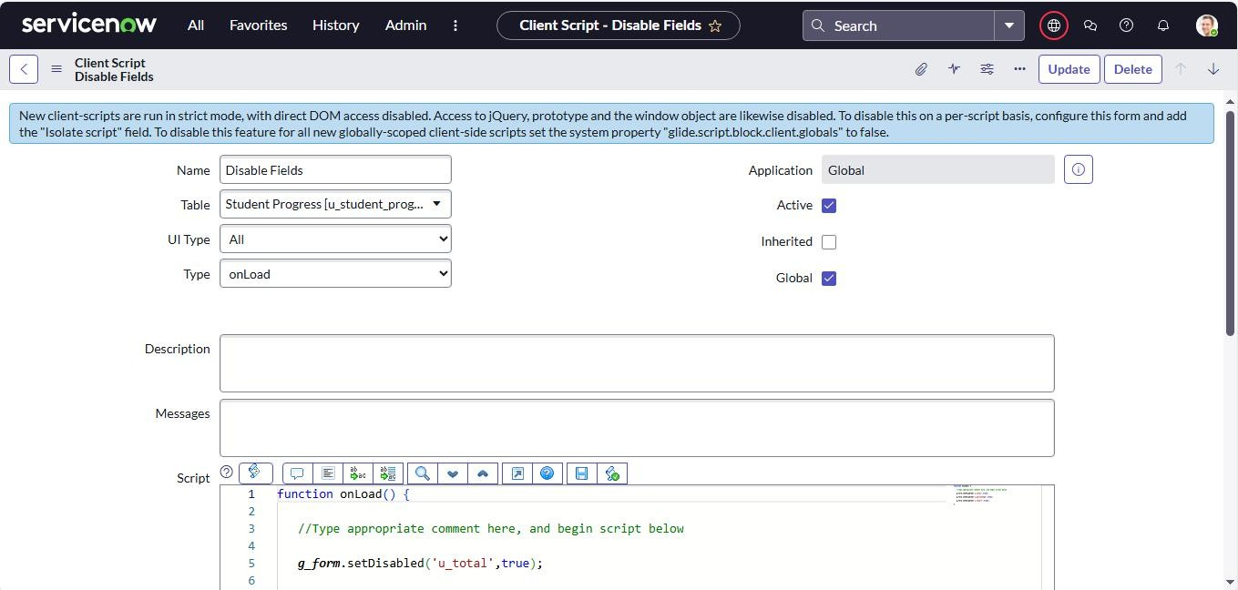

## Activity 4: Create “Total Update” Client Script for Student Progress Table

* Go to All → Client Scripts → New.
* Fill in the details for the script.
* Add the JavaScript code to calculate the Total marks automatically from subject field (Telugu, Hindi, English, Maths, Science, Social).
* The Script sets the value of Total based on the sum of all subjects.
* Enable Isolate Script and Save.

## Activity 5: Create “Result” Client Script for Student Progress Table

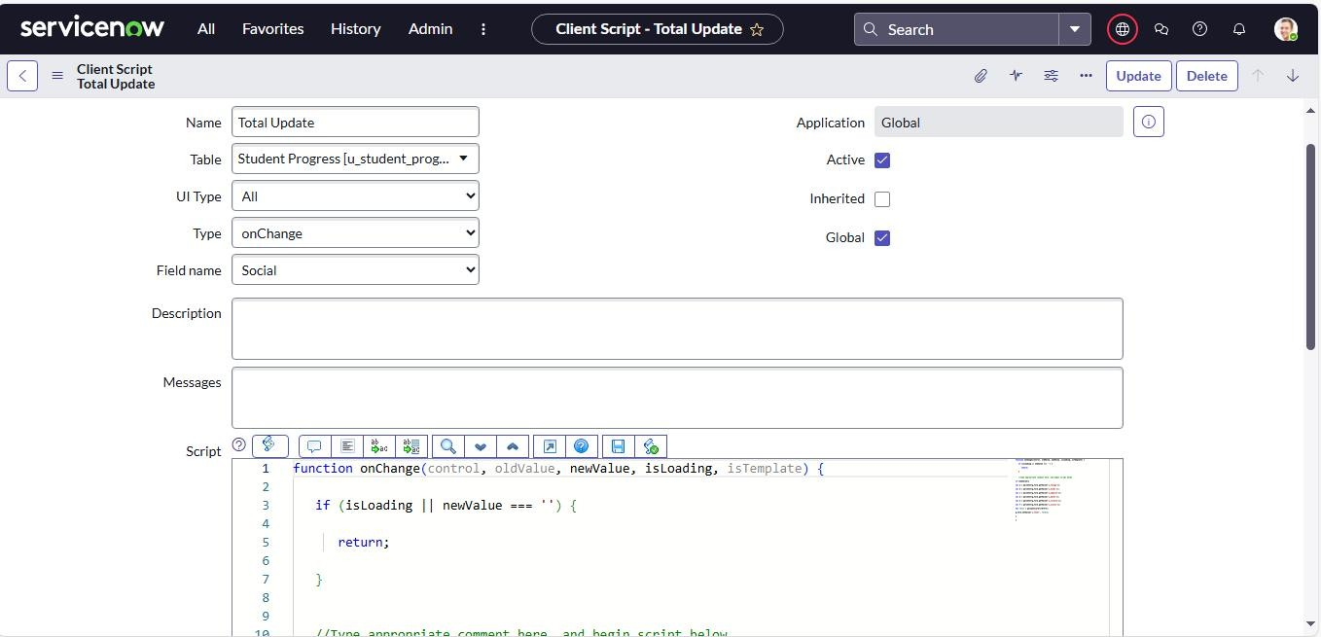

* Go to All → Client Scripts → New.
* Fill in the details for the script.
* Add the JavaScript code to set the Result field automatically based on Percentage
  + 0-59 → Fail
  + 60-100 → Pass
  + Outside range → show error message

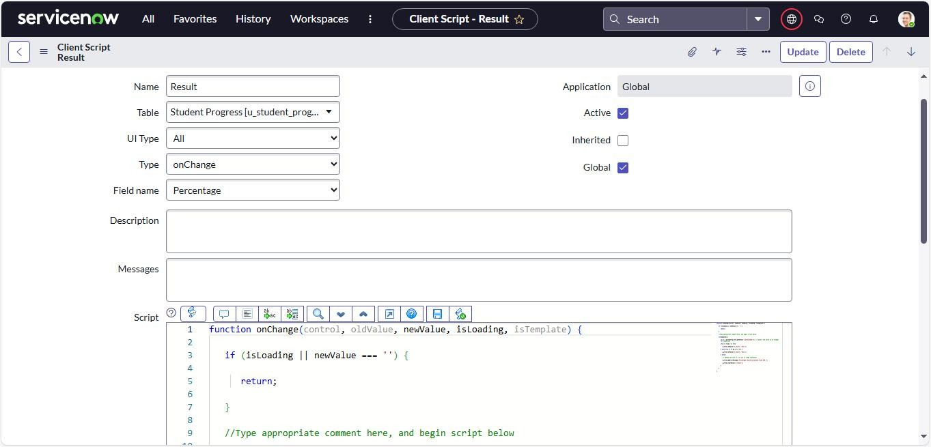

## Activity 6: Create “Percentage” Client Script for Student Progress Table

* Go to All → Client Scripts → New.
* Fill in the script details.
* Add the JavaScript code to calculate Percentage from the Total marks.
  + Formula: (Total ÷ 600) x 100
  + Sets the value in the Percentage field automatically.
* Enable Isolate Script and Save.

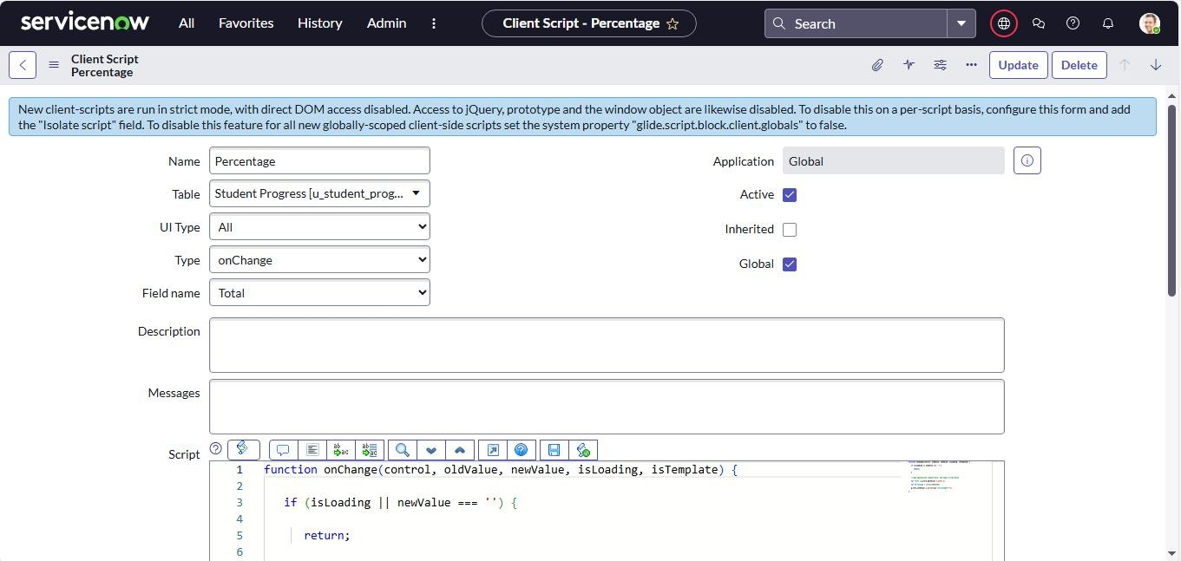

# Milestone 9: Result

Salesforce Table

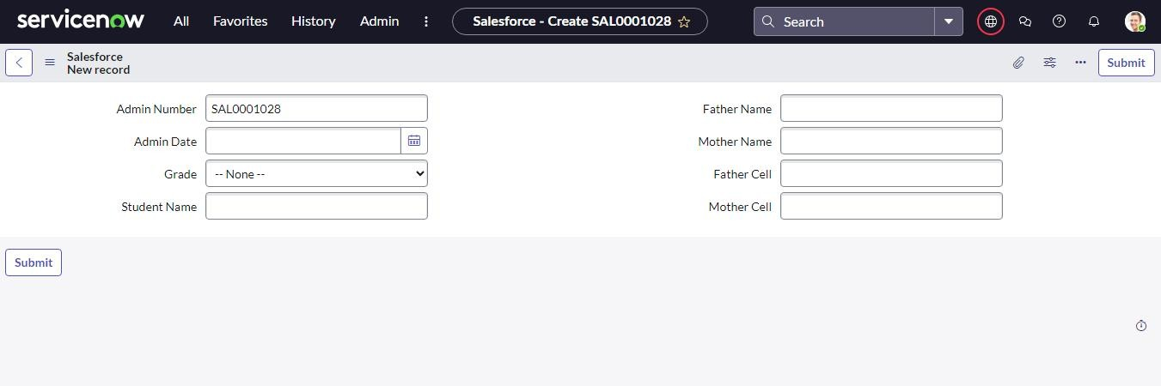

## Admission Table

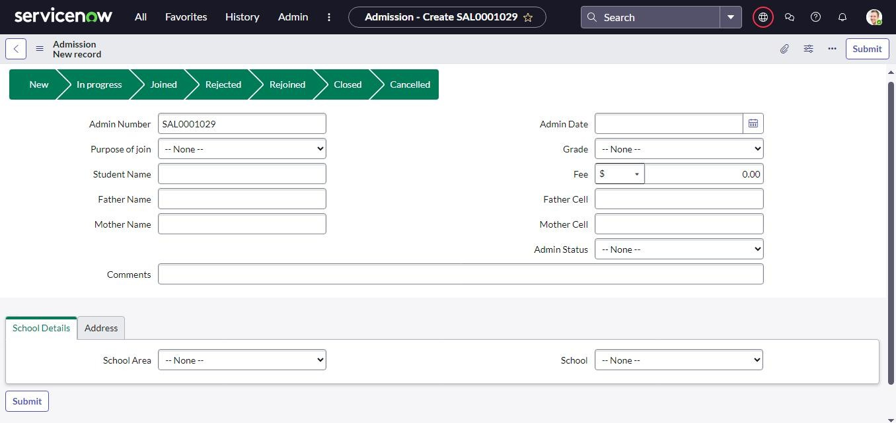

Student Progress Table

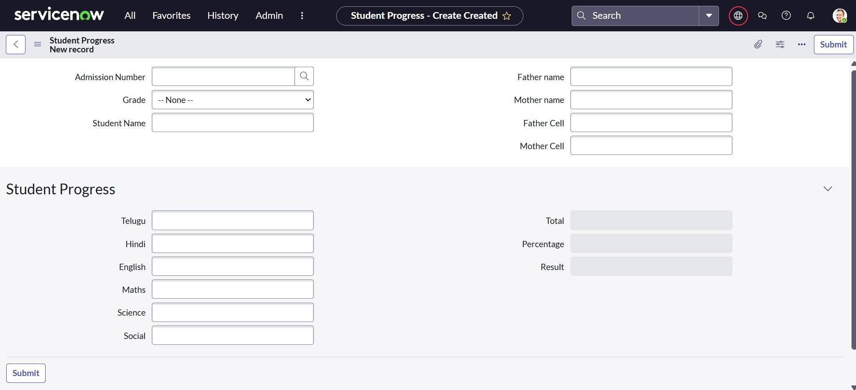

# Conclusion :

The project “Educational Organisation using ServiceNow” automated the admission and student progress process. By creating custom tables, forms, workflows, and client scripts, the system reduced manual work, improved accuracy, and made data management faster. This shows how ServiceNow can be used not only for IT services but also in the education sector.